**Beihai Park website project**

**History**

Consequently, many emperors in the feudal age of China constantly sought those mountains. For example, [Emperor Qin Shihuang](https://www.travelchinaguide.com/attraction/shaanxi/xian/terra_cotta_army/qin_shihuang_1.htm), the first emperor of the [Qin Dynasty](https://www.travelchinaguide.com/intro/history/qin/) (221 - 206 B.C.), wanted to live an eternal life and had sent people to look for the magic mountains but they failed. Then at his palace, he dug a large pool and piled up three earth hills in it to imitate the circumstances described in the legend.

Beihai Park was initially built in the Liao Dynasty (916 - 1125) and was repaired and rebuilt in the following dynasties including Jin, Yuan, Ming and Qing (1115 - 1911). The large-scale rebuilding in the reign of Emperor Qianlong of the [Qing Dynasty](https://www.travelchinaguide.com/intro/history/qing.htm) (1644 - 1911) generally established the present scale and pattern. In 1925, it was first opened to the public, attracting hundreds of thousands of visitors from all over the world every year.

Beihai Park covers an area of about 175 acres (70 hectares), more than half of which is taken up by the lake. In the middle of the lake and on the central axis of the whole park lies the Jade Flowery Islet, topped by the imposing White Dagoba which is the landmark. Besides the Jade Flowery Islet, it has four main scenic areas: the Eastern Shore Area, the Northern Shore Area, the [Botanical Garden](https://www.travelchinaguide.com/attraction/beijing/botanical-garden.htm) and the Circular City near the north gate. There are many famous and beautiful places you should not miss when touring it.

From: Travel China Guide

<https://www.travelchinaguide.com/attraction/beijing/beihai.htm>

**Pictures:**

**Picture for home page**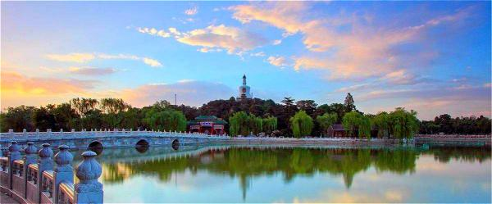

**Easy Tour China (** <https://www.easytourchina.com/scene-v7-beihai-park>)

Famous view

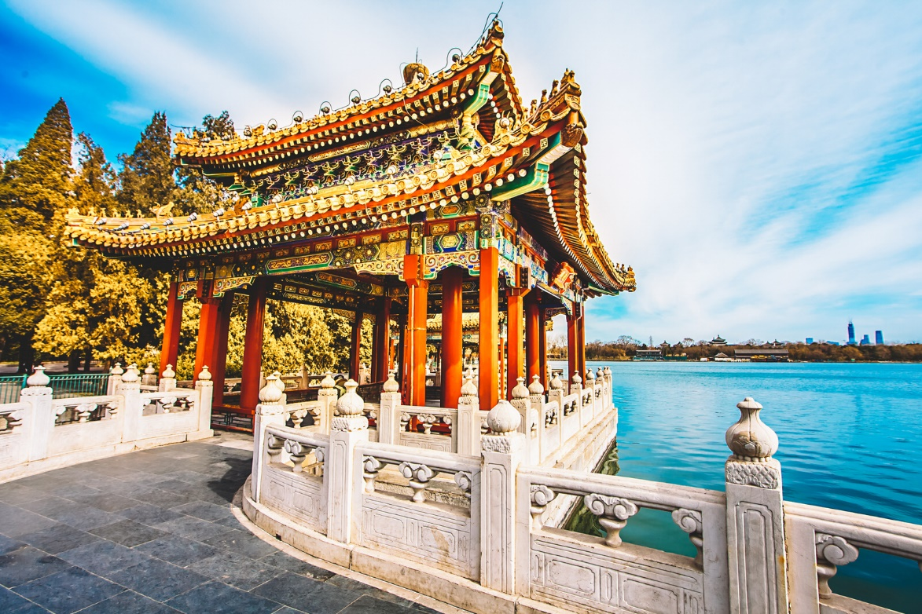

[https://www.wowabouts.com/explore/post-beihai-park 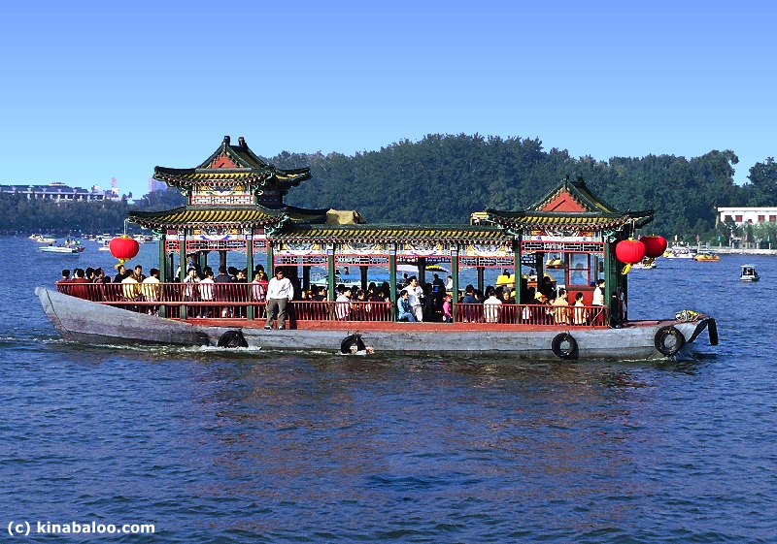](https://www.wowabouts.com/explore/post-beihai-park%20%20%20%20%20%20%20%20%20#)

Tour boat

<https://www.beijingbuzzz.com/bh19.html>

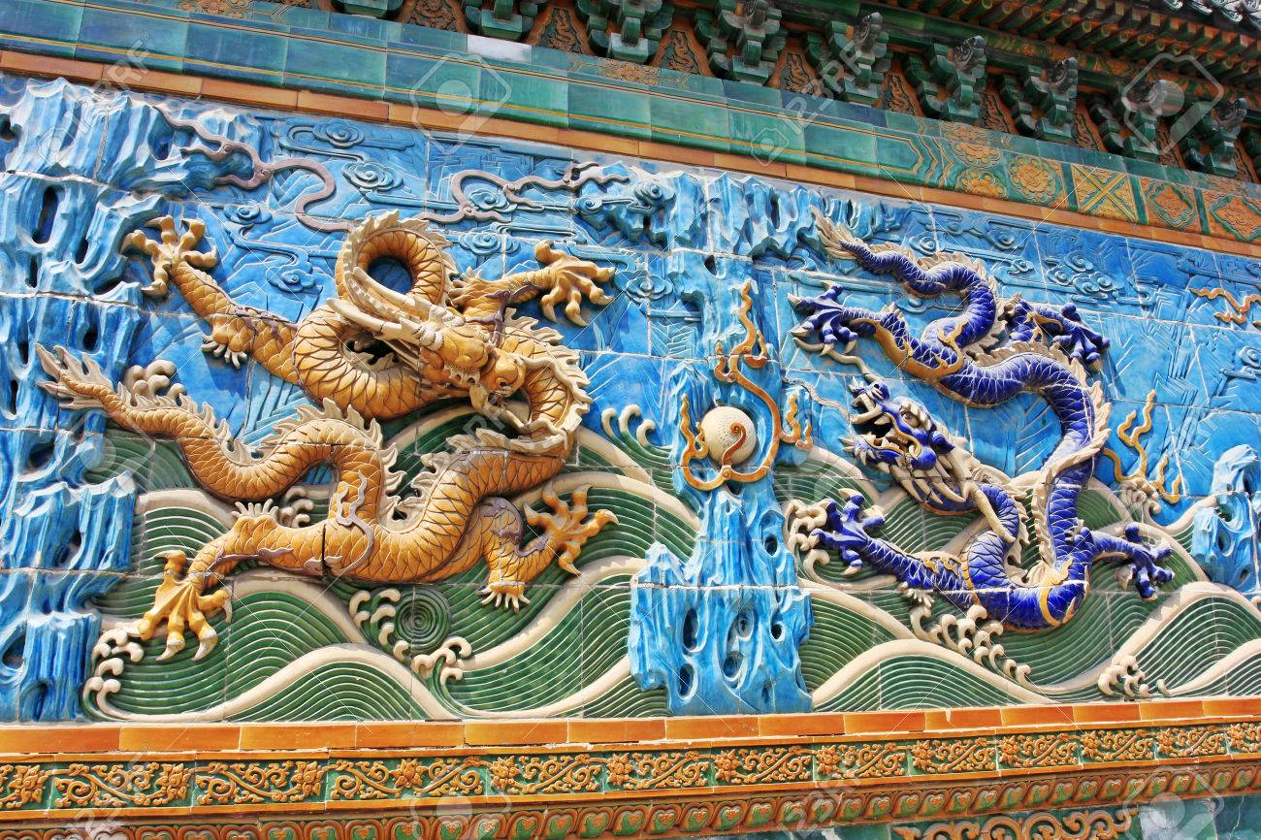

**Nine dragon boat**

<https://www.123rf.com/photo_30721670_nine-dragon-wall-jiulongbi-at-beihai-park-beijing-china.html>

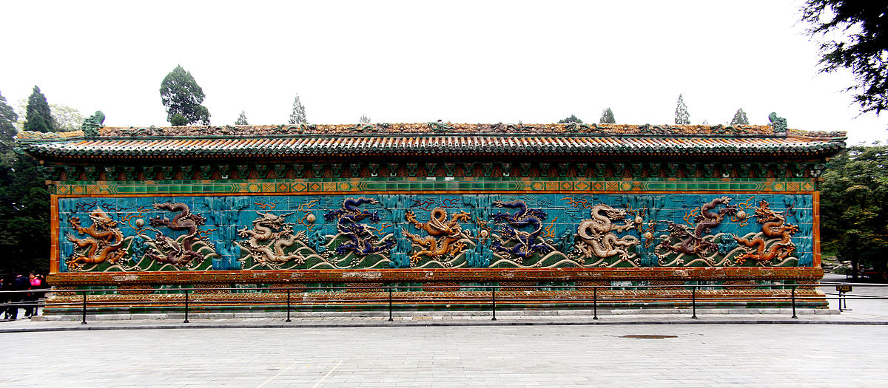

a type of [screen wall](https://en.wikipedia.org/wiki/Spirit_screen) with reliefs of nine different [Chinese dragons](https://en.wikipedia.org/wiki/Chinese_dragon). Such walls are typically found in [imperial Chinese](https://en.wikipedia.org/wiki/Imperial_Chinese) palaces and gardens.

<https://en.wikipedia.org/wiki/Nine-Dragon_Wall>

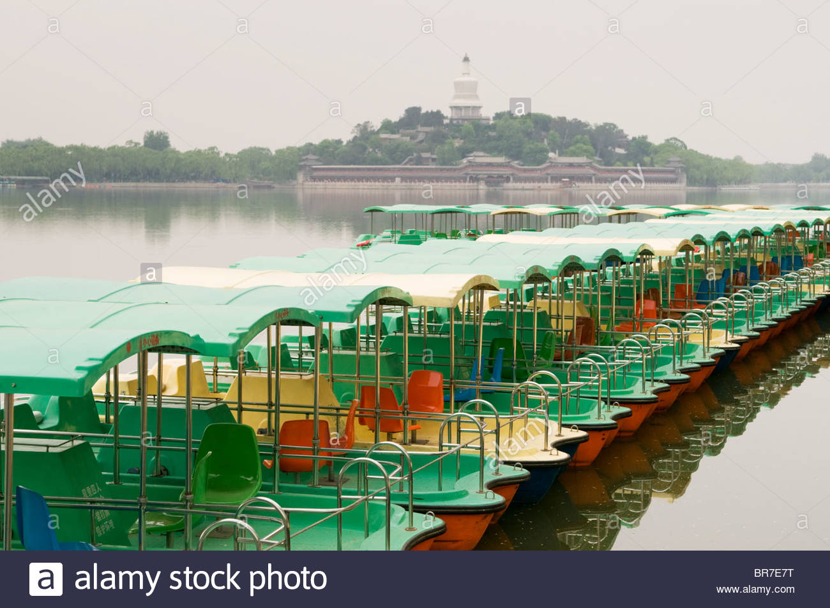

**Tourist boat for a boat trip**

<https://www.alamy.com/stock-photo-paddle-boats-on-a-lake-in-beihai-park-beijing-31512316.html>

The icy surface of the lake in Beihai Park melted half a month ago. The park has since replaced ship batteries and cleaned the boats. Saturday at 9 a.m., the park was officially open for boating. Many tourists came to enjoy the fun. This year, there are more than 460 vessels in the park, including electric, paddle and pedal boats. The electrical boats and pedal boats can take four to six people. Boats that come in shapes of lotus flowers and ducks are also available for entertainment.

In order to facilitate the rental of boats, the park has opened seven terminals. The sales booths are opened daily from 9 a.m. to 4 p.m. The lake closes at 5 p.m.

*For an electrical boat of 6 people, the price is a 400 yuan deposit and 160 yuan per hour. For 4 people, the deposit is 300 yuan and 100 yuan per hour.*

*For a pedal boat of 6 people, the price is a 300 yuan deposit and 120 yuan per hour. For 4 people, the deposit is 200 yuan and 60 yuan per hour.*

<https://news.cgtn.com/news/3d3d774d7a41444e33457a6333566d54/index.html>